News release
21 August 2020
SERGE BETSEN ACADEMY
A PROVEN MODEL IN CAMEROON NOW DEPLOYED IN MALI

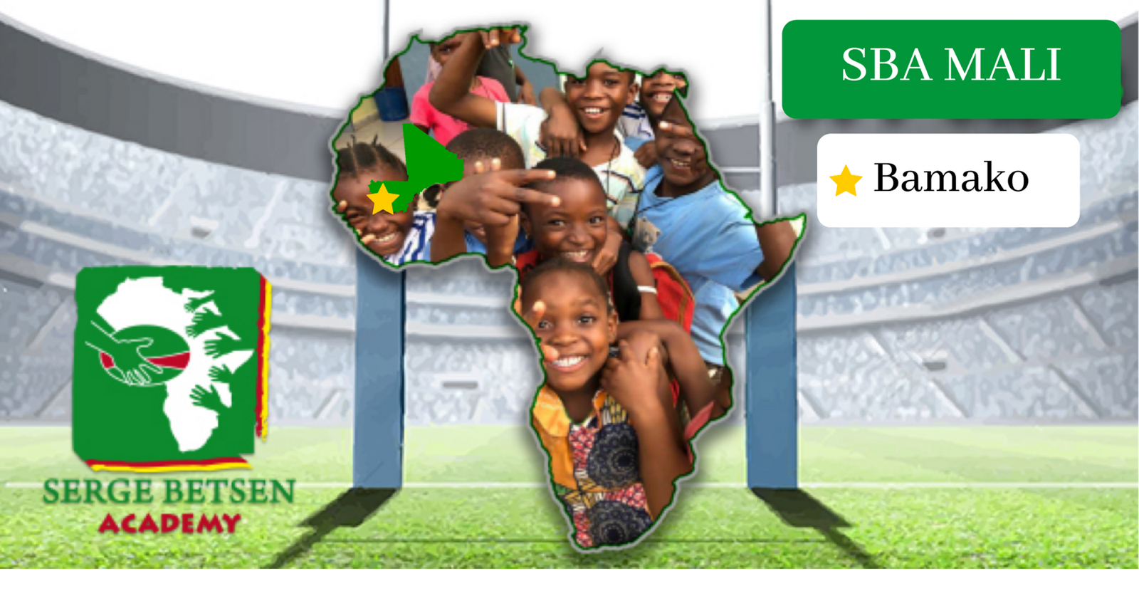
With more than 16 years’ experience in Cameroon, Serge Betsen Academy (SBA) opens a branch in Bamako, Mali. Since 2004, SBA has helped more than 6,500 disadvantaged children by using rugby to support their development and to offer a route to education and healthcare. It is Mali’s turn to benefit from this winning formula!

RUGBY AS MEANS OF SOCIAL INTEGRATION

Since 2004, SBA has supported over 6,500 children in its five centres in Cameroon, run four infirmaries and served 5,600 meals in the last two years thanks to the SBA Coop harvests (a farming cooperative run by mothers of SBA children), secured a baccalaureate success rate always above the national average, reaching 79% in 2019, built 5 wells and 3 water towers, provided 4.5 tons of supplies and insured 60 rugby players a year.

During the COVID-19 crisis, the centres closed from 18 March, to limit the spread of the virus. SBA ran an information campaign regarding preventative measures and provided support to the children and their families. Each child received a food bag every week, as well as soap, and SBA provided 367 reusable face masks, to help families avoid hunger and protect themselves and others. Since 17 June, only those children who are preparing an exam attend the centres. It is a final bit of support in strict sanitary conditions!

In normal times, 400 children benefit from SBA’s help each week. SBA welcomes children of all ages in after school support groups to help them succeed at school, pass their exams and follow their dreams. SBA has a particular focus on supporting girls so they can continue their education and enjoy a setting that is free of prejudices.
All children and their families receive good healthcare from the centres’ nurses, including vaccination and awareness-raising campaigns. For example, an antimalarial programme is in train at the five centres.
Rugby practice supports children in acquiring values and life bearings, for both boys and girls. This helps them build character. A “ Rugby for Kids” programme will start in September 2020 to allow 26 girls and 24 boys from disadvantaged families and aged between 2 and 13 to play rugby and to benefit from a structured education both on the rugby field and in the classroom. Together with their families, they will receive the same healthcare support as all other SBA children.

SERGE BETSEN, A RUGBY LEGEND CELEBRATED IN MALI

Before joining English side London Wasps, Serge Betsen excelled in French rugby with 63 caps for the national team, two Grand Slams and three titles in the 6 Nations Championship, and one of the highest honours of the French Republic, the Légion d’Honneur as Chevalier.
And the France player was also captain and three times French champion with Biarritz Olympique, for which he played all his career while in France and at the time of his first cap in 1997.
A “Knacker” with a big heart, Serge Betsen is French with Cameroonian origins and lives in London. But his soul has remained in Africa.

Serge Betsen is clearly a star in Cameroon… and in other African nations, as he recently discovered that Malian rugby players appreciate his on-field exploits.
In the lead-up to a Mali Cup in Bamako on 29 July 2017, the Hippos XV team from Bamako Rugby Club contacted Serge Betsen Academy to ask for permission to offer a trophy in his image. This trophy was the reward for Best Player in the Mali Cup.
Since then, SBA has been in close contact with Bamako’s Hippos XV and has carried out research into options for developing rugby in Mali. SBA met S.E. Mahamadou Nimaga, Mali’s ambassador to the US to learn more about the country and organised a field trip so that Serge Betsen could experience Mali’s rugby set-up.

A TRIGGERING TRIP

Serge Betsen, President of SBA and Odile Prévot, CEO therefore went on a field trip to Mali from 4 to 8 January 2020. Its objectives were to assess the situation for Mali’s youths, to identify their needs, to see young girls and boys from Bamako clubs Hippos XV and Anges Noirs [Black Angels] play rugby, to meet the club’s President and coaches so as to test the case for establishing an SBA centre in Bamako.
A further meeting with M. Arouna Modibo Touré, Mali’s Minister of Youth and Sports strengthened their view that an SBA presence in Mali would serve a real purpose and help convey a passion for rugby and SBA’s values to disadvantaged children in Mali.
At the end of the trip, Serge Betsen received a copy of the trophy in his image. This squared the circle in a way as it is because of this trophy that this adventure started!

OPENING A SBA CENTRE IN BAMAKO

In March 2020, SBA’s leadership met to vote on whether to start SBA Mali. Boubacar Traoré aka « PC », SBA’s representative in Mali, became Treasurer for SBA Mali.
Unfortunately, because of the COVID-19 pandemic, SBA delayed the official opening of the Bamako centre to October 2020, but the decision stands. Dr Seydou Sow, President of the Bamako Real sports association, granted SBA Mali access to a rugby field at the Modibo Keïta stadium. Set in Bamako’s Djikoroni neighbourhood, young girls and boys playing for Anges Noirs rugby will be able to train there from the beginning of the school year. SBA will set up a classroom near the stadium entrance to welcome 25 girls for after school tutoring every afternoon.
Next step: organising healthcare for those children.

SBA now lends a hand to disadvantaged children in Mali. More lives will improve thanks to rugby! A beautiful story is in the making.
MEDIA CONTACT
Mailys Finel : mailys@sergebetsenacademy.org
contact@sergebetsenacademy.org

www.sergebetsenacademy.com
Facebook | Twitter | LinkedIn | Instagram

